G GOLDHAWK INTERNATIONAL ADVANCE INFORMATIONINFORMATION

GOLD OF THE GODS

Golden Lotus Foundation

Key Points

- The THIRD VOLUME in the highly acclaimed JAVA GOLD series

- Fabulous jewels and prosperity in Indonesia from 7th to 15th century

Book Description

The third volume, Hidden Treasures, in the Java Gold series book explores exquisite ritual objects and statues,
many of which are totally unique.

These hidden treasures from private collections document Java gold from the 7th to the 15th century. As is the case with courtly
paraphernalia, the vast majority of Hindu-Buddhist images were used by the highest Javanese royalty during a period of fabulous prosperity.

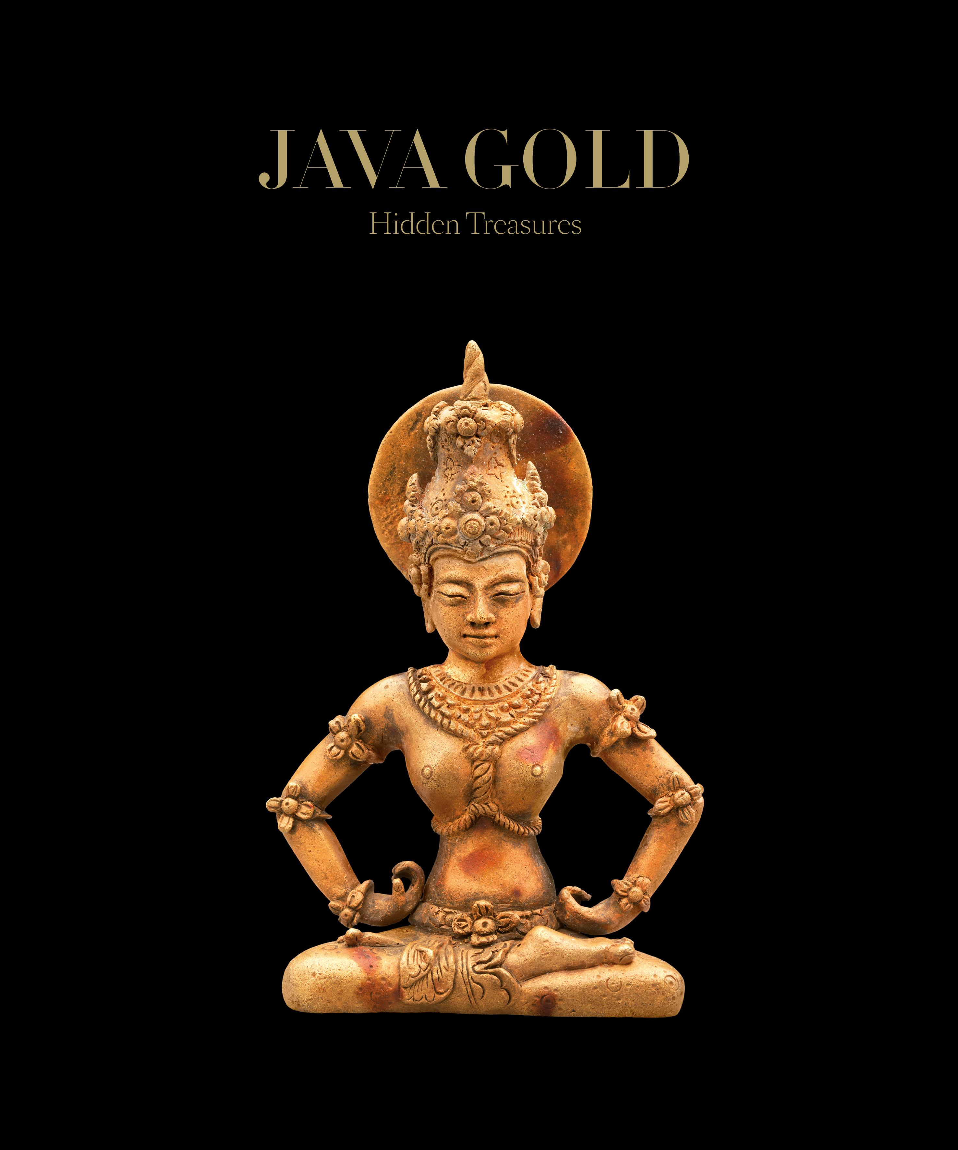

Category:
Decorative Arts

Title: Java Gold 3:
Hidden Treasures

Author:
Golden Lotus Foundation

ISBN: 9789811406652

Format: Hardcover

Price: £35/$49.95

Size: 305 mm x 254 mm

Publisher:
GOLDEN LOTUS FDN

Release Date:
16 SEPTEMBER 2019

Territory: ALL

For more information of this book and our other titles, please visit www.goldhawkinternational.com

